Azure Storage Account

Storage account services are nothing but,

Blob

File share

Table and Queue

Difference between Standard and Premium

Redundancy: Azure Storage always stores multiple copies of your data to protect it from problems like hardware issues, power or network outages, and even natural disasters. This Redundancy ensures that your storage account meets availability and durability.

Choosing a redundancy option means balancing cost and availability**. Lower-cost options might have less protection, while higher-availability options keep data safer but cost more.** The best choice depends on how much protection and access you need for your data.

* How your data is replicated within the primary region.
* When you want to replicate your data from a primary region to a secondary region, you should choose geographically distant region, to protect against regional disasters (geo-replication).
* Whether your application **requires read access to the replicated data in the secondary region during an outage in the primary region (geo-replication with read access).**

**All services in a storage account share the same redundancy setting. If different resources need different redundancy levels, it's best to place them in separate storage accounts.**

* **Redundancy in the primary region**

So, in Azure storage account the data is always replicated 3 times in the primary region. Azure storage offers two options for your date to be replicated in the primary region.

* Local Redundant Storage (LRS)
* Zone Redundant Storage (ZRS)

LRS: Replicates the data to one or more available zones located in the primary region. LRS is the least expensive replication option but isn’t recommended for applications requiring High availability or durability.

ZRS: Replicates the data into their Availability Zones in the Primary region. For applications requiring high availability or durability, Microsoft recommends using ZRS in the primary region, and also replicating to a Secondary region.

**Note**

Microsoft recommends using ZRS in the primary region for Azure Data Lake Storage workloads.

Local Redundant Storage:

**Locally redundant storage (LRS):** keeps multiple copies of your data to a availability zone within a single Azure region. Although there is no option to choose, you preferred the availability zone. **to protect against hardware failures like disk or server issues**. It's the most cost-effective option, offering 11 nines (99.999999999%) durability per year. However, since all copies stay in the same data center, LRS doesn’t protect against large-scale disasters like fires or floods. For better protection, Microsoft recommends using ZRS, GRS, or GZRS.

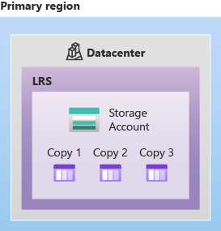

LRS is a good choice for the following scenarios:

* Choose LRS if your app stores **data that can be easily recreated in case of data loss**. It's a cost-effective option when durability isn't critical.
* If your application is restricted to replicating data only within a region due to data governance requirements, consider choosing LRS.

Zone-redundant storage

**Zone-redundant storage (ZRS)**: replicates the data within your storage accounts to **three availability zones located in the primary region of your choice**. Each availability zone isolated from others and with independent cooling, powering and networking. ZRS offers high availability or durability.

When you utilize ZRS, your data remains accessible for both read and write operations even if a zone becomes unavailable.

**Microsoft recommends using ZRS in the primary region for scenarios that require high availability. ZRS is also recommended for restricting replication of data to a particular region to meet data governance requirements.**

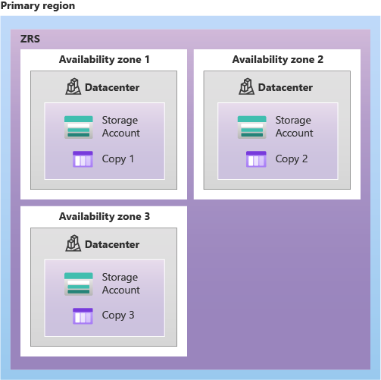

**ZRS by itself might not fully protect your data against a regional disaster where multiple zones are permanently affected.**

[Geo-zone-redundant storage](https://learn.microsoft.com/en-us/azure/storage/common/storage-redundancy#geo-zone-redundant-storage) (GZRS) uses ZRS in the primary region and geo-replicates your data to a secondary region. GZRS is available in many regions and is recommended for protection against regional disasters.

**Redundancy in a secondary region**

Redundancy Options can help provide a high availability or durability of your applications. In many regions, you can copy the data to a secondary region located hundreds of miles away from the primary region. Copying your storage account to a secondary region ensures that your data remains high availability or durability during a complete regional outage or a disaster in the primary region isn't recoverable.

When you create a storage account, you choose the primary region. Azure automatically assigns a secondary paired region, and this pairing can’t be changed.

* **Azure Storage offers two options for copying your data to a secondary region**

**Geo-redundant storage (GRS):** Copies your data in the primary region using LRS (3 copies), then asynchronously copies it to a secondary region, where it’s also stored using LRS (3 more copies).

**Geo-zone-redundant storage (GZRS):** Copies your data across their availability zones in the primary region using ZRS. It then copies your data in the secondary region. Within the secondary region, your data is copied three times using LRS

When you utilize GRS or GZRS, the data in the secondary region isn’t available for read and write operations unless there’s a failover to the secondary region.

For read access to the secondary region, configure your storage account to use read-access geo-redundant storage (RA-GRS) or read-access geo-zone-redundant storage (RA-GZRS).

If the primary region goes down, you can trigger a failover to the secondary region. Once the failover is complete, the secondary becomes the new primary, allowing full read and write access again.

**Geo-redundant storage**

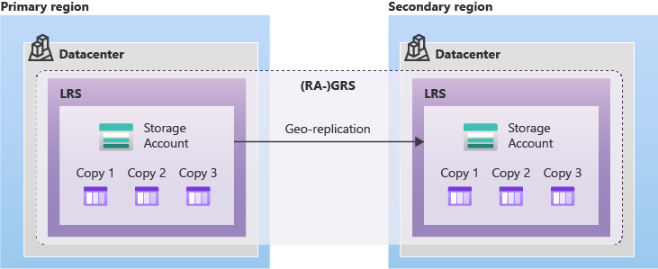

**Geo-zone-redundant storage**

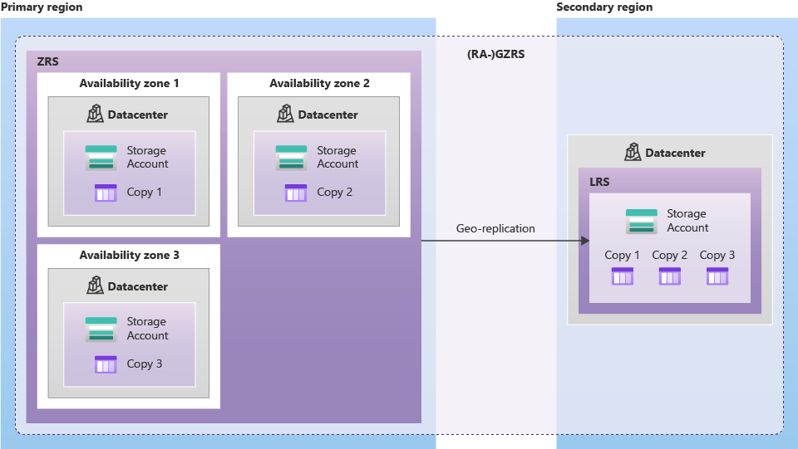

Geo-redundant storage (GRS or GZRS) protects your data by copying it to a secondary region. However, this backup copy isn’t accessible to users or applications when an outage occur in the primary region unless you trigger a failover. During failover, Azure updates the DNS provided by Azure storage so the secondary region becomes the new primary—but your data will be unavailable during this process.

If your app needs high availability even during a regional outage, use **RA-GRS** or **RA-GZRS**. These allow **read access** to the secondary region at all times, so your data remains readable even if the primary region goes down.

Here's a simple comparison of Azure Storage redundancy options:

Here’s an updated comparison table including **RA-GRS** and **RA-GZRS**, which provide **read access** to the secondary region:

| **Redundancy Type** | **Primary Region Storage** | **Secondary Region Storage** | | | | **Sync Type** | | | | **Read Access to Secondary** | | **Use Case** |
| --- | --- | --- | --- | --- | --- | --- | --- | --- | --- | --- | --- | --- |
| **LRS** | 3 copies in a single zone (LRS) | None | | | | Synchronous | | | | No | | Basic, low-cost protection |
| **ZRS** | 3 copies across zones (ZRS) | None | | | | Synchronous | | | | No | | High availability within region |
| **GRS** | 3 copies in one zone (LRS) | 3 copies in paired region (LRS) | | | | Async to secondary | | | | No | | Disaster recovery (no read access) |
| **RA-GRS** | 3 copies in one zone (LRS) | 3 copies in paired region (LRS) | | | | Async to secondary | | | | **Yes** | | Read access during primary region outage |
| **GZRS** | 3 copies across zones (ZRS) | 3 copies in paired region (LRS) | | | | Async to secondary | | | | No | | High availability + disaster recovery |
| **RA-GZRS** | 3 copies across zones (ZRS) | 3 copies in paired region (LRS) | | | | Async to secondary | | | | **Yes** | | Best durability + read access for DR scenarios |
|  | | | **LRS** | **ZRS** | **GRS** | | **RA-GRS** | **GZRS** | **RA-GZRS** | |
| Blob storage (including Data Lake Storage) | | | ✅ | ✅ | ✅ | | ✅ | ✅ | ✅ | |
| Queue storage | | | ✅ | ✅ | ✅ | | ✅ | ✅ | ✅ | |
| Table storage | | | ✅ | ✅ | ✅ | | ✅ | ✅ | ✅ | |
| Azure Files | | | ✅ 1 | ✅ 1 | ✅ | |  | ✅ |  | |
| Azure managed disks | | | ✅ | ✅ 2 |  | |  |  |  | |
| Azure Elastic SAN | | | ✅ | ✅ |  | |  |  |  | |

Azure Storage account Types:

Here’s a simplified and cleanly formatted **text version** of the storage account types, supported services, redundancy options, and usage guidance:

**1. Standard General-Purpose v2**

* **Supported Services:** Blob Storage (including Data Lake Storage Gen1), Queue Storage, Table Storage, Azure Files
* **Redundancy Options:** LRS, GRS, RA-GRS, ZRS, GZRS, RA-GZRS
* **Usage:**  
  This is the standard storage account type for blobs, file shares, queues, and tables.  
  Recommended for most Azure Storage use cases.  
  If you need NFS support for Azure Files, use the premium file shares account type.

**2. Premium Block Blobs**

* **Supported Services:** Blob Storage (including Data Lake Storage Gen1)
* **Redundancy Options:** LRS, ZRS
* **Usage:**  
  Premium storage for block and append blobs.  
  Ideal for high transaction rates, small object sizes, or scenarios needing low-latency access.

**3. Premium File Shares**

* **Supported Services:** Azure Files
* **Redundancy Options:** LRS, ZRS
* **Usage:**  
  Premium storage account for file shares only.  
  Best for enterprise-grade or high-performance apps.  
  Supports both SMB and NFS file shares.

**4. Premium Page Blobs**

* **Supported Services:** Page blobs only
* **Redundancy Options:** LRS, ZRS
* **Usage:**  
  Designed for page blobs (e.g., used by Azure IaaS VMs).  
  Choose this for workloads requiring consistent high performance.

**Data Lake Storage is recommends for a Big data analytics, built on Azure Blob Storage.**

.